TARS Prototype Instruction Manual

Introduction

The movie Interstellar is truly a beautiful piece of cinema. An often overlooked aspect of that movie is the robot TARS which serves as a mechanical companion to the main protagonists of the film. Through this project I strived to create a working prototype of the robot. I built a partially mobile version, however the servo motors I currently possess, unfortunately do not have enough torque to allow the robot to walk similar to the movie.

Manual

To control the Raspberry Pi, which in turn controls the robot, we will use a VNC desktop sharing system. This means that you will be able to control the Raspberry Pi using a separate computer or device, and the interface through which you will do this will be a graphical one. In this tutorial, we will use an Android phone to control the TARS Robot.

Necessary Materials

1. 1 USB-C Cable
2. 1 MICRO-HDMI Cable
3. 1 TARS bot
4. 1 mouse
5. 1 keyboard

Basic Setup

1. Find the side port opening in the bot and plug the USB-C cable into the USB-C port in the Raspberry Pi as follows: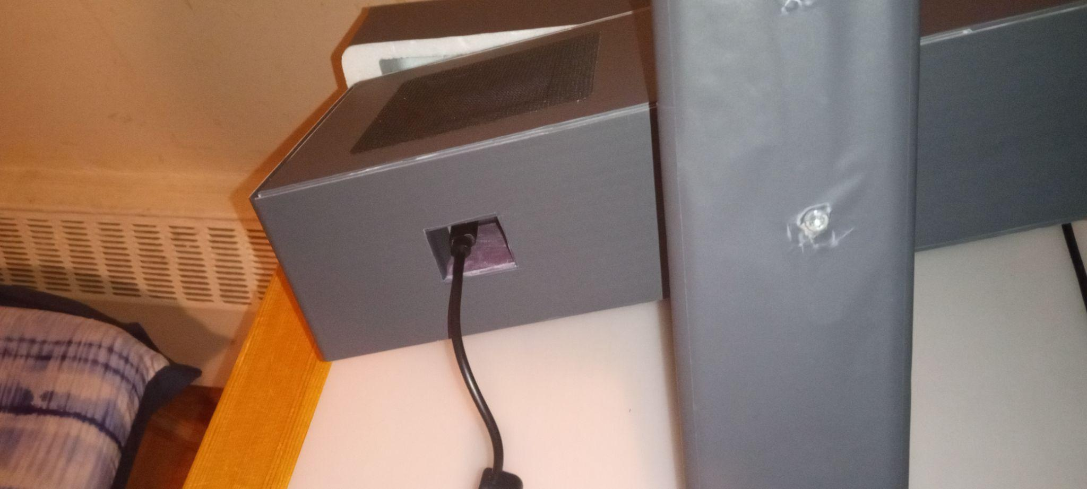

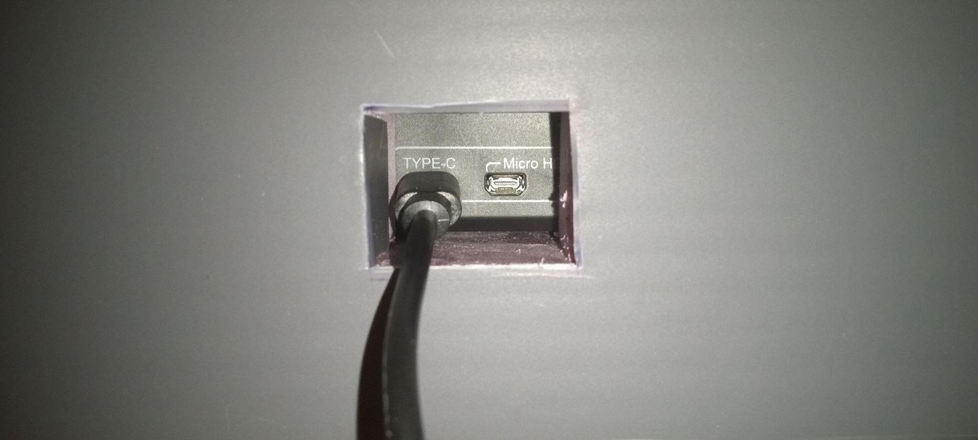

1. Plug the other end of the cable into the power supply at the top of the TARS bot, or into the nearest outlet.

Connecting to the Raspberry Pi using VNC Connection

1. Install the RealVNC app on your Android device.
2. In the app, click on the plus button, and add a new device. The IP address of the Raspberry Pi is 192.169.2.150.110.
3. Enable Hotspot on your device.
4. Connect the Raspberry Pi to a monitor (using a micro-hdmi cable), and a keyboard/mouse (using USB ports).
5. Connect the Raspberry Pi to the hotspot.
6. Connect to the Raspberry Pi using the RealVNC app connection, the hostname is: pi, and the password: 123456
7. Unplug the HDMI cable from the Pi, and place it back into the case.
8. Place the Raspberry Pi into the Pi area of the cutout as follows:

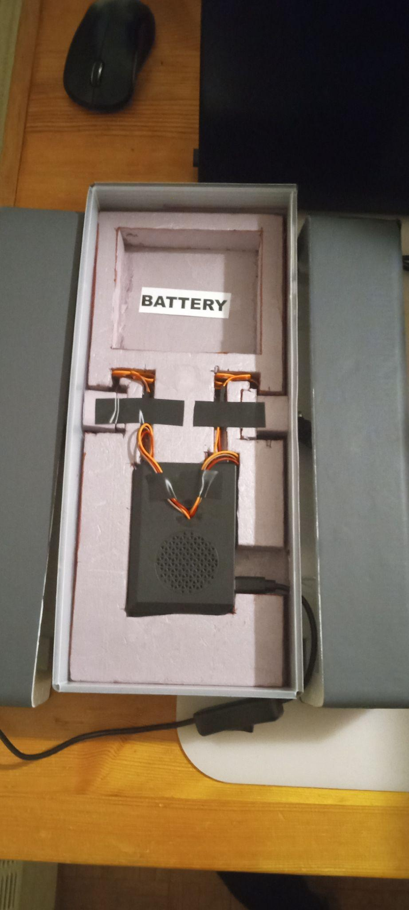

1. Make sure to plug in the wires sticking out of the Raspberry Pi, into the servo motor wires.
2. Place the case lid on top of the bot as in the second picture above.
3. Complete [basic setup] from the start of the tutorial.

Starting up the Program:

1. On your Android device, you should now see a Raspberry Pi screen.
2. On the screen navigate to the program called TARS_Graphics3.py.
3. Run the program.
4. The following screen should appear:



1. Use the buttons to control the movement of the robot.